**CLI Commands for creating Asp .Net Core Empty App   
(MVC Application)**

1. Created Folder DikshaAssignment
2. Checked the list of .net core projects available   
   **dotnet new –list**
3. Inside >DikshaAssignment Created .sln file  
     
   **dotnet new sln -n DikshaAssignment**
4. Created Asp .net core 3.0 web with empty template with C# language  
   **dotnet new web -f netcoreapp3.0 -lang C# -n DikshaAssignment**
5. Checked the files created inside the app **cd DikshaAssignment  
   >DikshaAssignment>ls**
6. Added DikshaAssignment.csproj file into DikshaAssignment.sln file  
    **cd ..  
   dotnet sln DikshaAssignment.sln add ./DikshaAssignment\DikshaAssignment.csproj"**
7. Installed package for Database Connection  
   **dotnet add package Microsoft.EntityFrameworkCore.SqlServer -v 3.0.0   
   dotnet add package Microsoft.EntityFrameworkCore.Tools -v 3.0.0**
8. Open folder in vs code  
   **code .**
9. Restore packages **dotnet restore**
10. Run the Application  **dotnet run**
11. Build the Application **dotnet build**
12. Publish Code into publish folder  
    **dotnet publish -c release -r win10-x64 -o PublishAppFiles**
13. Move inside publish folder and find the .exe file **cd publish  
    >publish> dir *.exe**
14. Run exe file **./DikshaAssignment.exe**

**Database Migrations using EF by CLI**

1. To add the migrations install below package  **dotnet tool install --global dotnet-ef --version 3.0.0**
2. To add migrations and update database  
   **dotnet ef migrations add CreateDatabase   
   dotnet ef migrations add CreateDatabase   
   dotnet ef database update**

**Test Project using ClI**

1. Created the Test Project named DikshaAssignment.Test **dotnet new mstest -lang C# -n DikshaAssignment.Test**
2. Moved to >DIkshaAssignment.Test directory and checked the files in the folder **cd DikshaAssignment.Test  
   >DikshaAssignment.Test>ls**
3. Added DikshaAssignment.Test to sln file **cd ..  
   dotnet sln DikshaAssignment.sln add .\DikshaAssignment.Test\DikshaAssignment.Test.csproj**
4. Installed Moq and FluentAssertion packages  
   **dotnet add package Moq   
   dotnet add package FluentAssertion**
5. 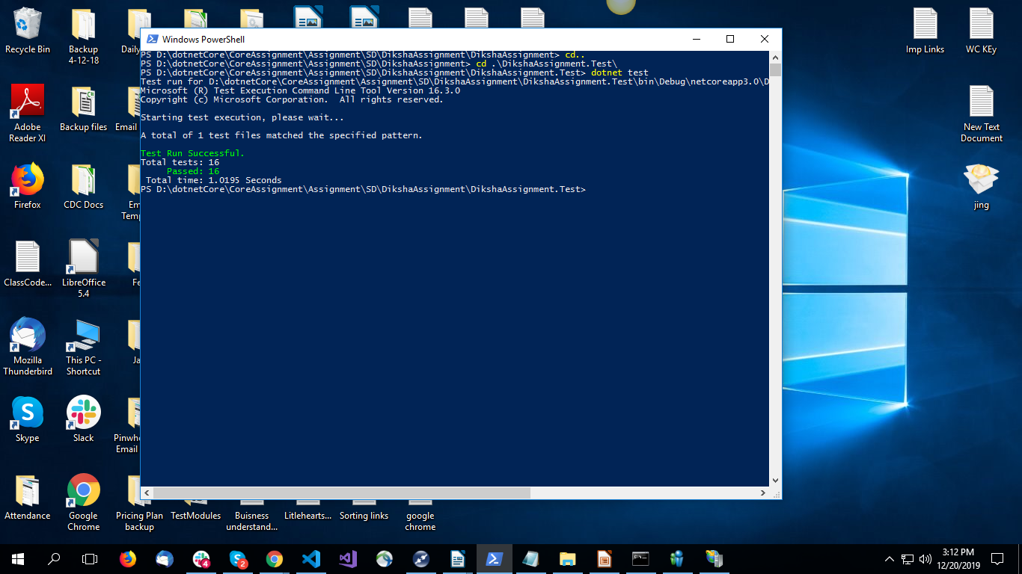To run test cases  
   **dotnet test**

**Swagger implementation**

1. 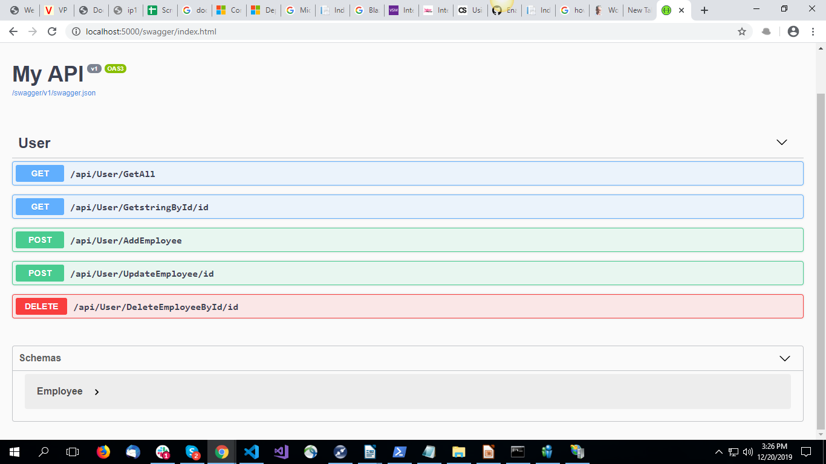Install swashbuckle package above 5.2 version for Asp .net Core 3.00 application **dotnet add package Swashbuckle.AspNetCore --version 5.0.0-rc2**

**To Deploy Code on IIS**

1. **Install Hosting bundle from below link and run exe** [**https://github.com/dotnet/core/blob/master/release-notes/2.2/2.2.6/2.2.6.md**](https://github.com/dotnet/core/blob/master/release-notes/2.2/2.2.6/2.2.6.md)
2. **Configure ISS and Hosting environment from Control panel**
3. **Enter command inetmgr opening IIS**
4. **Add new website by providing proper path of published file of project “PublishAppFiles” and IP to access the site**
5. **Right Click and browse the website**

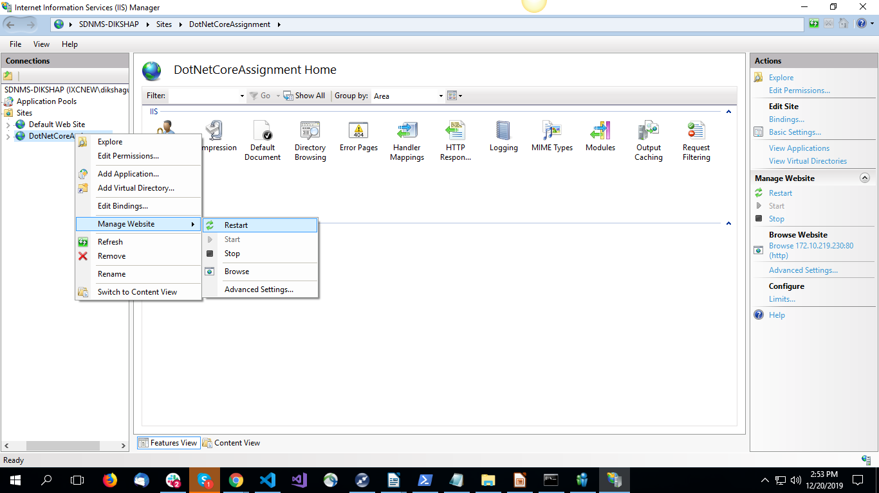

**Docker File Commands (Docker Play)**

1. **Git Clone  
    git clone https://github.com/DikshaGunnewar/CoreAssignment.git**
2. **Jump into folder  
   cd CoreAssignment/Assignment/SD/DikshaAssignment/**
3. **Build Dockerfile  
   docker build -t sample-image .**
4. **To create container   
   docker run -d -p 5000:80 --name sample-container sample-image**
5. **To check current active container  
   docker ps**
6. **To stop container  
   docker stop sample-container**
7. **To remove container  
   docker rm container**

**Docker file executed**

